Lunar Month
# Source: AI Source: Provided by: [Data Path: Persons Table -> ID Column: 1, Name_En Column: Motasem Essam] -> From: [ChatGPT] on [7/17/2026]
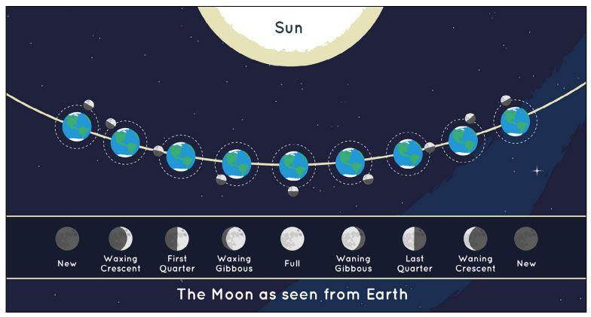
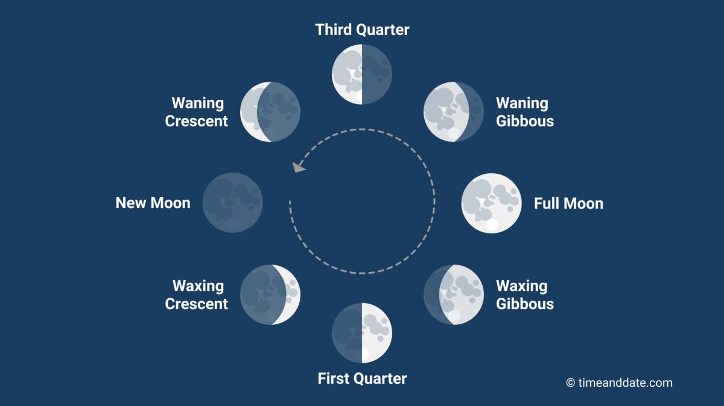
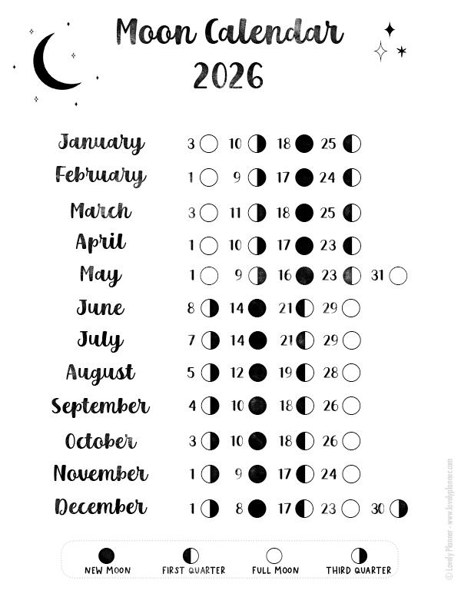
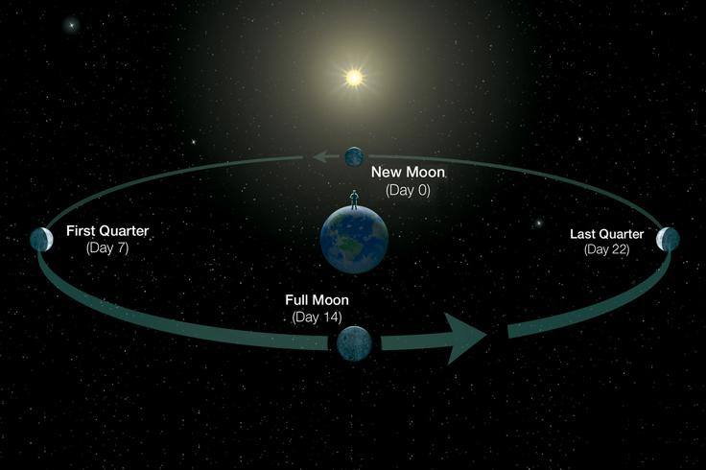
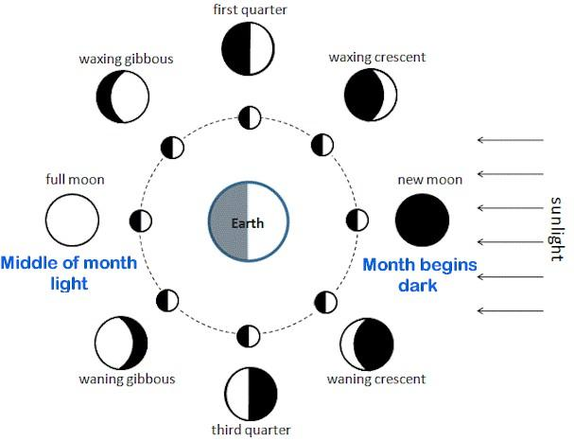
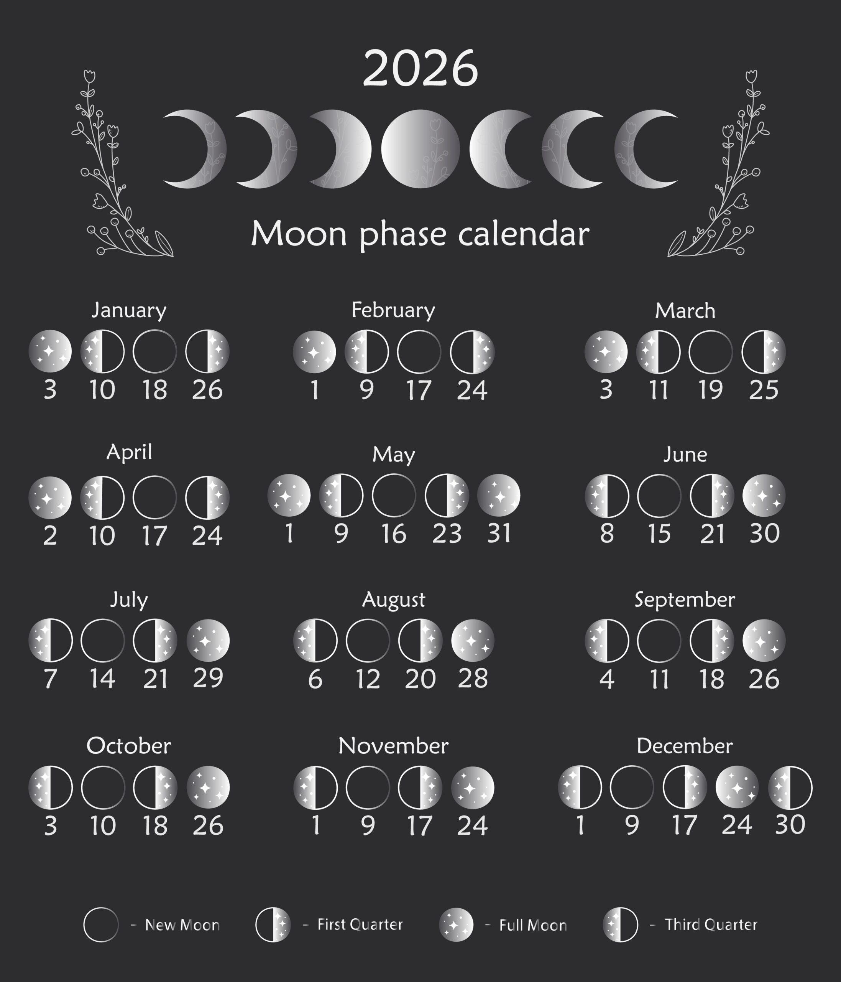
A Lunar Month is a unit of time based on the Moon's phases. It is the time required for the Moon to complete one full cycle of phases—from one New Moon to the next New Moon. Lunar months form the foundation of lunar and lunisolar calendar systems.
The average length of a lunar month is approximately:
$$29.5306\text{ days}$$

Definition
# Source: AI Source: Provided by: [Data Path: Persons Table -> ID Column: 1, Name_En Column: Motasem Essam] -> From: [ChatGPT] on [7/17/2026]
A Lunar Month is the period between two successive New Moons, representing one complete cycle of the Moon's phases.

Astronomical Basis
# Source: AI Source: Provided by: [Data Path: Persons Table -> ID Column: 1, Name_En Column: Motasem Essam] -> From: [ChatGPT] on [7/17/2026]
A lunar month is based on the synodic month, which measures the Moon's phase cycle as observed from Earth.
Average length:
$$29.5306\text{ days}$$
Because this is not a whole number of days, calendar systems that use lunar months typically alternate between 29-day and 30-day months.

Lunar Phases
# Source: AI Source: Provided by: [Data Path: Persons Table -> ID Column: 1, Name_En Column: Motasem Essam] -> From: [ChatGPT] on [7/17/2026]
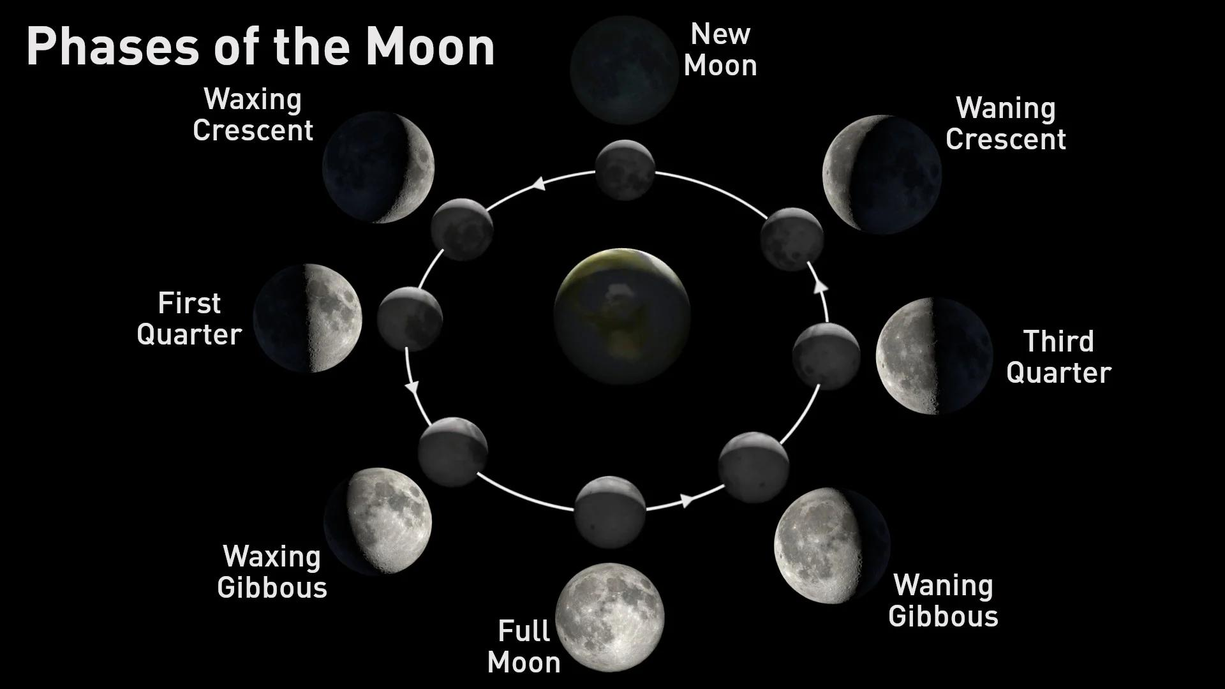
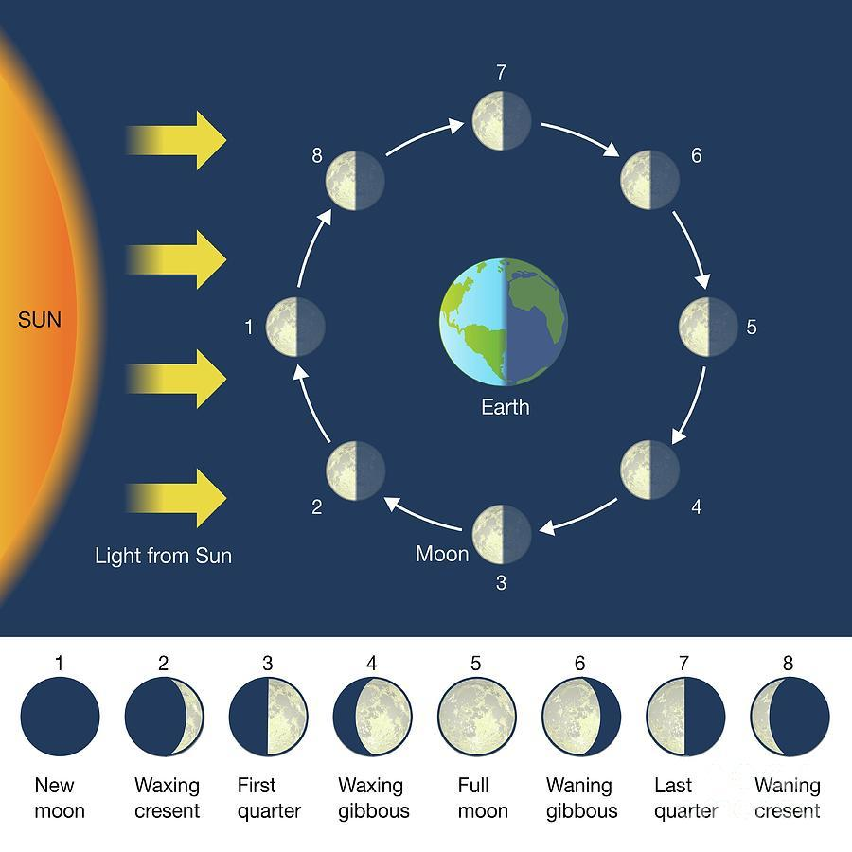
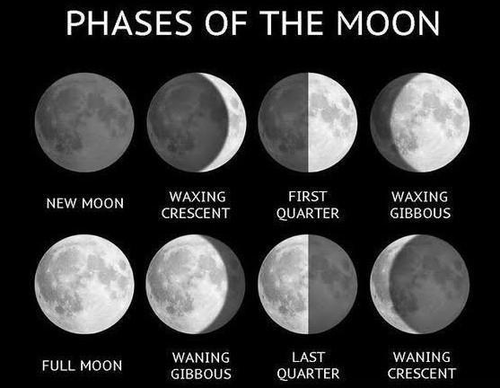
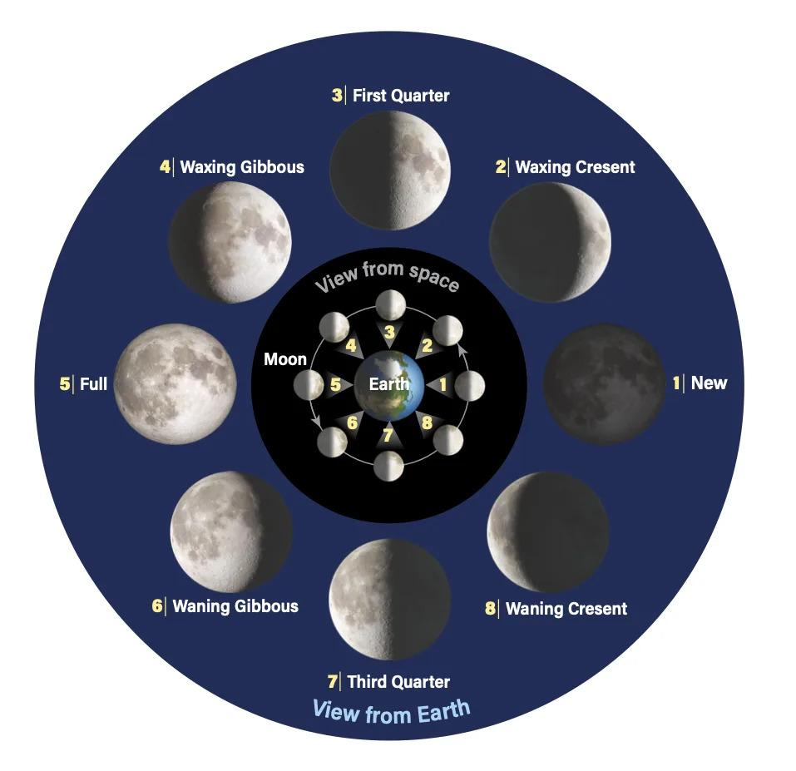
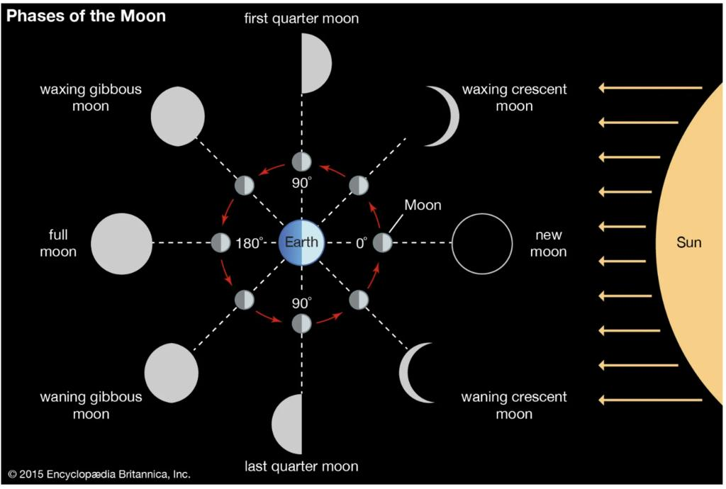
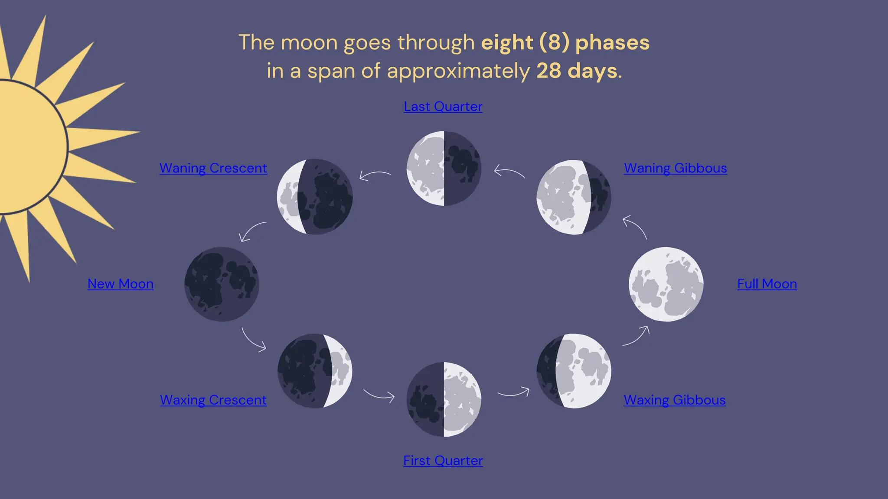
During one lunar month, the Moon passes through the following principal phases:
- New Moon
- Waxing Crescent
- First Quarter
- Waxing Gibbous
- Full Moon
- Waning Gibbous
- Last (Third) Quarter
- Waning Crescent
The cycle then repeats with the next New Moon.

Length of a Lunar Month
# Source: AI Source: Provided by: [Data Path: Persons Table -> ID Column: 1, Name_En Column: Motasem Essam] -> From: [ChatGPT] on [7/17/2026]
Average duration:
$$29.5306\text{ days}$$
In practical calendar systems, a lunar month is usually either:
- 29 days, or
- 30 days

Relationship to the Lunar Year
# Source: AI Source: Provided by: [Data Path: Persons Table -> ID Column: 1, Name_En Column: Motasem Essam] -> From: [ChatGPT] on [7/17/2026]
A lunar year consists of 12 lunar months.
Average length:
$$12×29.5306≈354.37\text{ days}$$
This is about 11 days shorter than a solar year.

Use in Calendar Systems
# Source: AI Source: Provided by: [Data Path: Persons Table -> ID Column: 1, Name_En Column: Motasem Essam] -> From: [ChatGPT] on [7/17/2026]
Lunar months are used in:
Lunar Calendars
Examples:
- Islamic (Hijri) Calendar
Lunisolar Calendars
Examples:
- Chinese Calendar
- Hebrew Calendar
- Traditional Hindu Calendars
In lunisolar calendars, leap months are added periodically to keep the calendar aligned with the seasons.

Beginning of the Month
# Source: AI Source: Provided by: [Data Path: Persons Table -> ID Column: 1, Name_En Column: Motasem Essam] -> From: [ChatGPT] on [7/17/2026]
Traditionally, a lunar month begins with:
- The New Moon, or
- The first visible crescent moon, depending on the calendar system.
Some modern calendars determine the start of the month using astronomical calculations rather than direct observation.

Applications
# Source: AI Source: Provided by: [Data Path: Persons Table -> ID Column: 1, Name_En Column: Motasem Essam] -> From: [ChatGPT] on [7/17/2026]
Lunar months are used for:
- Religious observances
- Traditional festivals
- Cultural ceremonies
- Historical records
- Astronomical observations

Advantages
# Source: AI Source: Provided by: [Data Path: Persons Table -> ID Column: 1, Name_En Column: Motasem Essam] -> From: [ChatGPT] on [7/17/2026]
Lunar months:
- Closely follow the Moon's natural cycle.
- Are easy to relate to visible changes in the night sky.
- Support religious and cultural traditions.

Limitations
# Source: AI Source: Provided by: [Data Path: Persons Table -> ID Column: 1, Name_En Column: Motasem Essam] -> From: [ChatGPT] on [7/17/2026]
Lunar months:
- Do not evenly divide the solar year.
- Cause purely lunar calendars to drift through the seasons.
- Require leap months in lunisolar calendars to maintain seasonal alignment.

Comparison with Other Types of Months
# Source: AI Source: Provided by: [Data Path: Persons Table -> ID Column: 1, Name_En Column: Motasem Essam] -> From: [ChatGPT] on [7/17/2026]
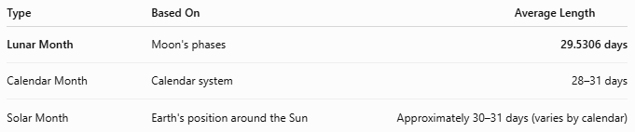
Type | Based On | Average Length
Lunar Month | Moon's phases | 29.5306 days
Calendar Month | Calendar system | 28–31 days
Solar Month | Earth's position around the Sun | Approximately 30–31 days (varies by calendar)

Common Mistakes
# Source: AI Source: Provided by: [Data Path: Persons Table -> ID Column: 1, Name_En Column: Motasem Essam] -> From: [ChatGPT] on [7/17/2026]
- Confusing a lunar month with a calendar month.
- Assuming every lunar month has exactly 30 days.
- Believing lunar months stay aligned with the seasons without adjustment (only lunisolar calendars do this by adding leap months).

Interesting Facts
# Source: AI Source: Provided by: [Data Path: Persons Table -> ID Column: 1, Name_En Column: Motasem Essam] -> From: [ChatGPT] on [7/17/2026]
- The word month is derived from the word Moon.
- Many ancient civilizations based their earliest calendars on lunar months.
- The Moon completes about 12.37 lunar months during one solar year.

Key Points
# Source: AI Source: Provided by: [Data Path: Persons Table -> ID Column: 1, Name_En Column: Motasem Essam] -> From: [ChatGPT] on [7/17/2026]
Key Points
- A Lunar Month is based on the Moon's phases.
- It lasts approximately:
$$29.5306\text{ days}$$
- Most lunar calendars use months of 29 or 30 days.
- Twelve lunar months form a lunar year of about 354 days.
- Lunar months are the foundation of:
  - Lunar calendars
  - Lunisolar calendars

Conclusion
# Source: AI Source: Provided by: [Data Path: Persons Table -> ID Column: 1, Name_En Column: Motasem Essam] -> From: [ChatGPT] on [7/17/2026]
A Lunar Month is the natural time interval defined by the Moon's cycle of phases, lasting about 29.53 days from one New Moon to the next. It serves as the basic unit of time in lunar and lunisolar calendar systems and has played a central role in human timekeeping for thousands of years. While lunar months closely follow the Moon's visible changes, they do not perfectly match the solar year, making additional adjustments necessary in lunisolar calendars to maintain seasonal alignment.

